PAIN ASSESSMENT TOOL

PATIENT NAME | ADMISSION # | DATE
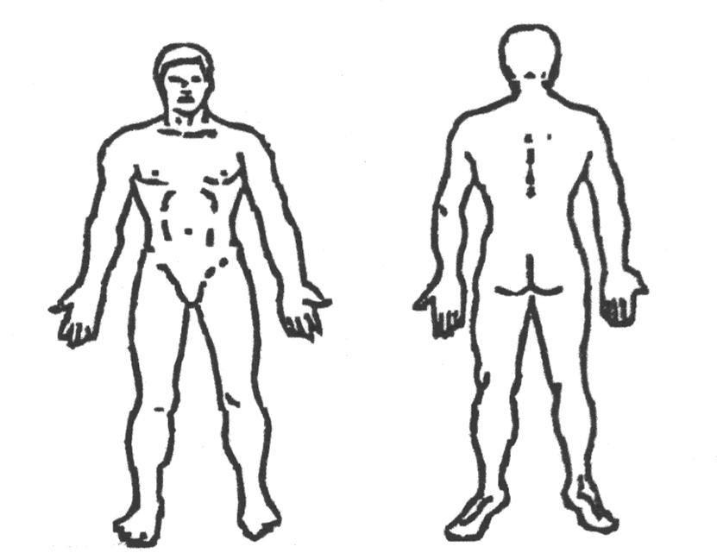
PAIN LOCATION

Indicate on figures all pain sites
and label (A, B, C, etc.)
DESCRIPTION OF PAIN
Pain is worse  - Morning  - Afternoon  - Evening  - Night |  |  |  |  | Onset of Pain  - Acute – 48 hours – 6 months  - Chronic – longer than 6 months  Pain feels better when _____________________________________  _________________________________________________________  Pain feels worse when _____________________________________  _________________________________________________________
Patient Description of Pain – check all that apply
- Sharp  - Dull  - Ache  - Tingles  - Stings |  |  |  |  | - Tender  - Throbbing  - Burning  - Other _________________________________________________  _________________________________________________________
- Patient unable to describe/respond
Intensity: |  |  |  |  |  |  |  |  |  |  | PAIN SCALE
 |  |  |  |  |  |  |  |  |  |  |  |  |  |  |  |  |  |  |  |  |  |  |  |  |  |  | 
NO PAIN |  |  |  |  |  |  |  |  |  |  |  |  |  |  |  |  |  |  |  |  |  |  |  |  |  |  |  |  |  | SEVERE
 | 0 |  | 1 |  |  |  | 2 |  |  | 3 |  |  | 4 |  | 5 |  |  |  | 6 |  |  | 7 |  | 8 |  | 9 |  |  | 10
 |  |  |  |  |  | 1-3  Mild |  |  |  |  |  |  | 4 | 4-6  Moderate |  |  |  |  |  |  |  |  |  | 7-10  Severe |  |  |  |  | 10
 |  |  |  |  |  |  |  |  |  |  |  |  |  |  |  |  |  |  |  | Pain Rating ______________________
NURSE performing pain assessment ___________________________________________
©Copyright 2002 Carstens, Inc. All rights reserved. |  |  |  |  |  |  |  |  |  |  |  |  |  |  |  |  | carstens.com

